**ASSESSMENT – INSURANCE MANAGEMENT SYSTEM**

TASK for creating SQL QUERY

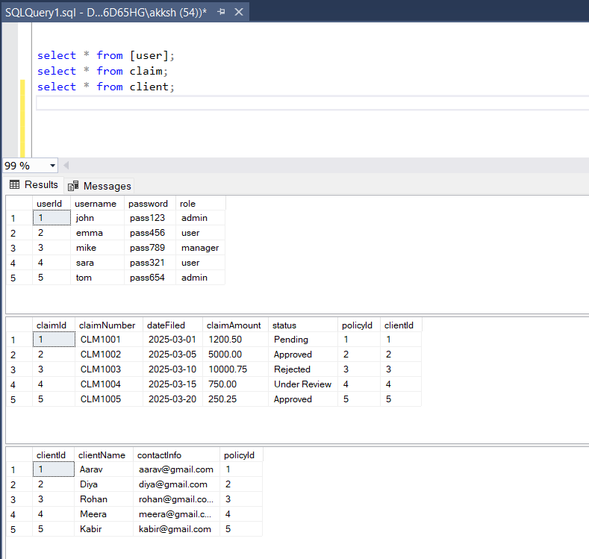

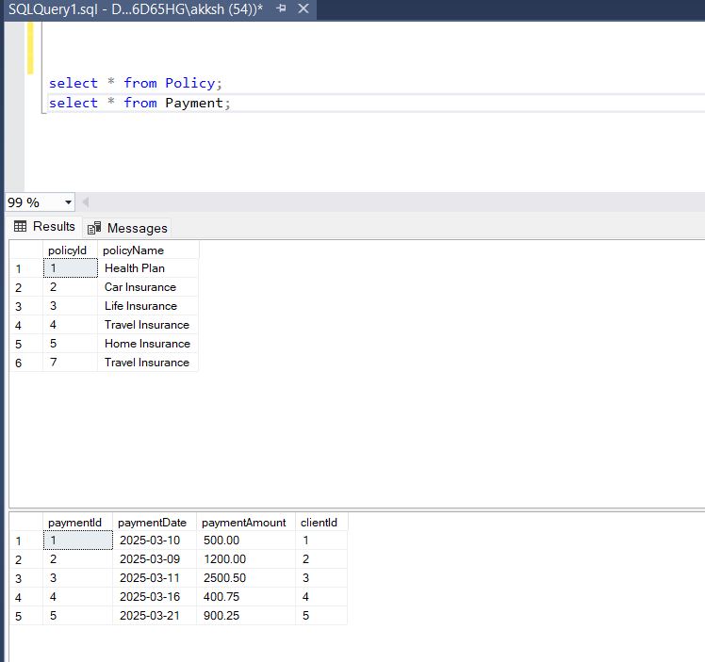

TASK for MODELS CREATION AND OUTPUT

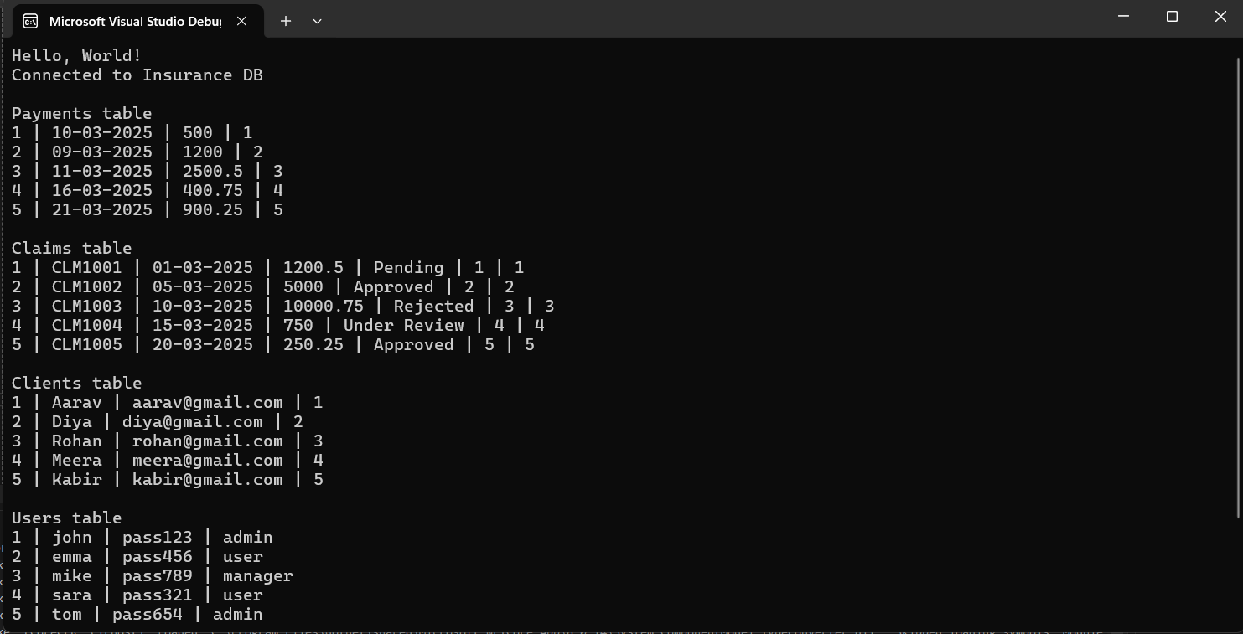

TASK FOR IMPLEMENTATION (method created and implemented)

1. Create policy

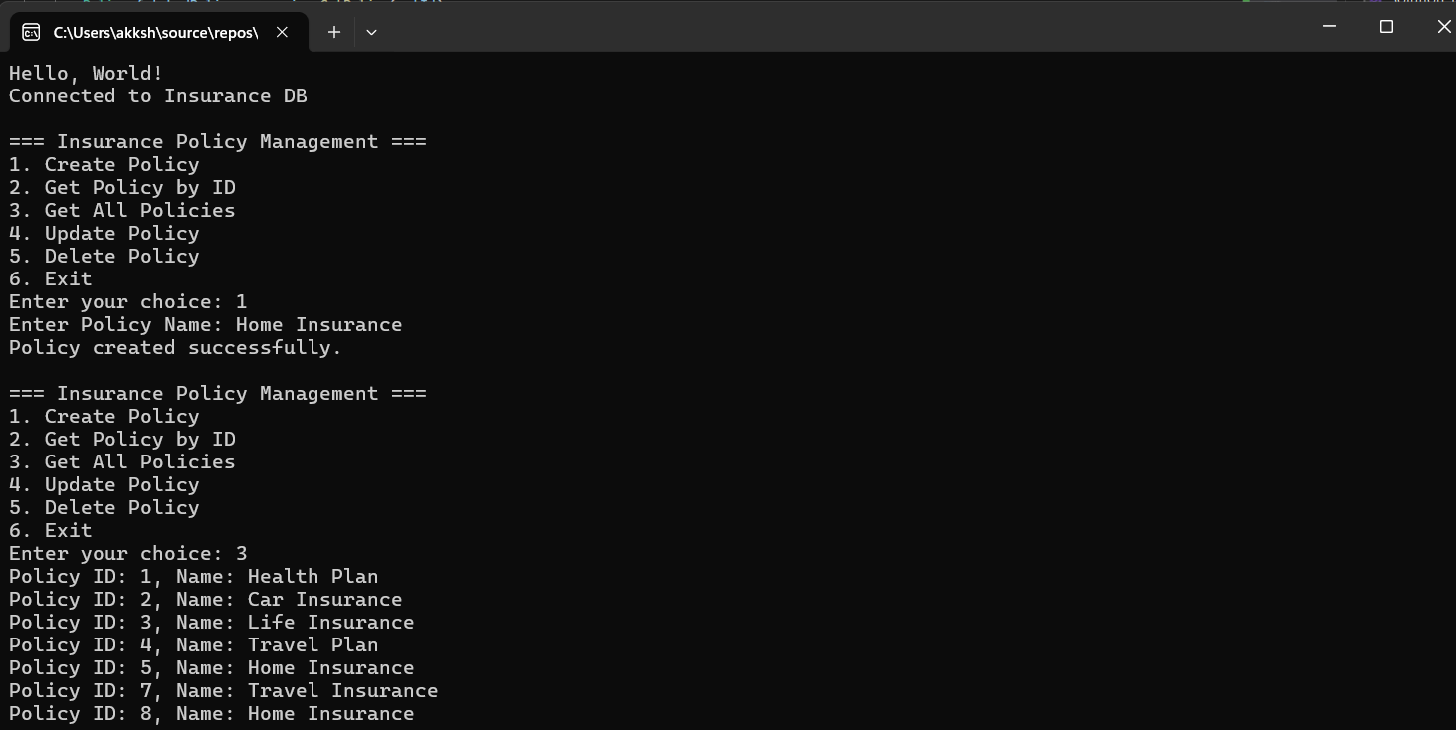

1. Get Policy by ID

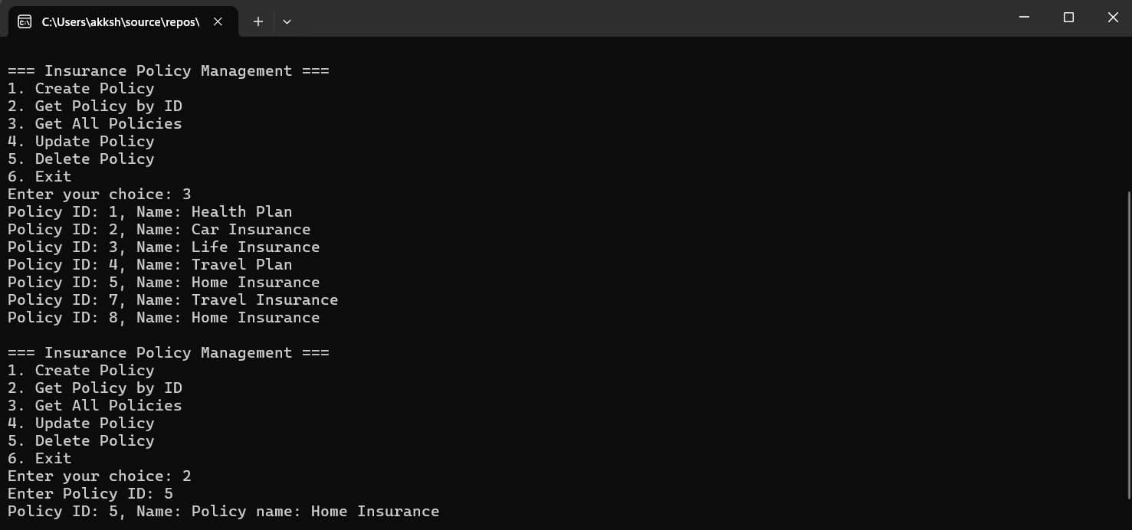

1. Get all policies

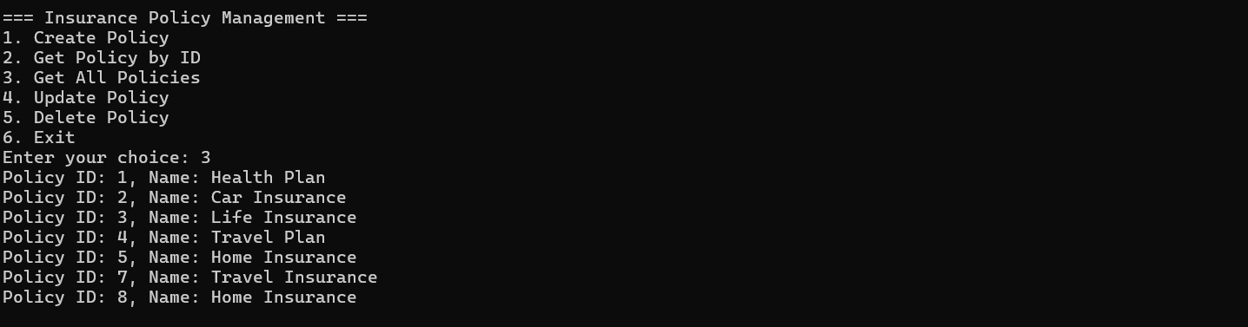

1. Update policy

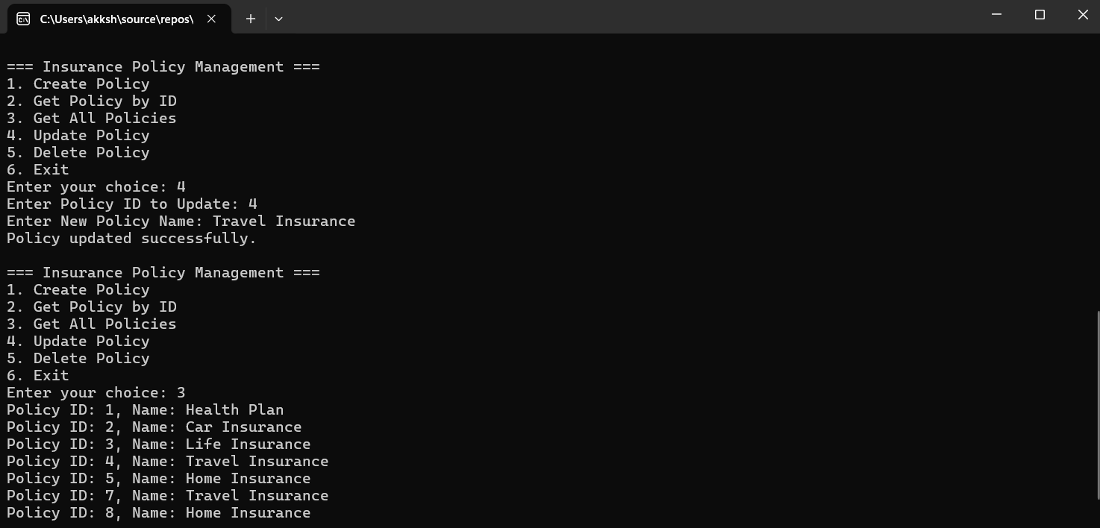

1. Delete policy

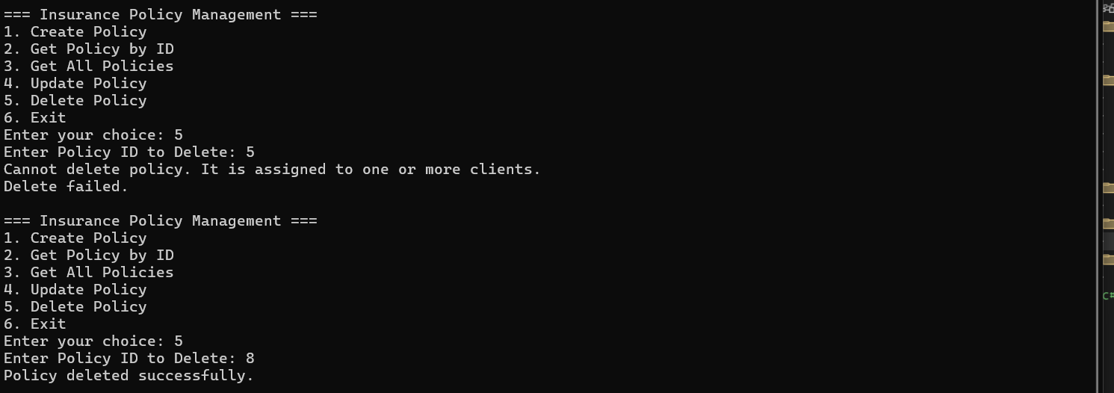

TASK for EXCEPTION HANDLING

